**LAB 4**

1. **Write a java program to calculate cyclic sum of a number. The number should be entered using scanner class.**

**Source code:**

**import java.util.Scanner;**

**class CyclicSum**

**{**

**int reqSum(int n)**

**{**

**int i,j=0;**

**int count = 0;**

**int m = n;**

**while(m>0)**

**{**

**i = m%10;**

**j = j*10+i;**

**m = m/10;**

**}**

**int temp = j;**

**int rem;**

**while(j>0)**

**{**

**temp = j;**

**while(temp>0)**

**{**

**rem = temp%10;**

**count+= rem;**

**temp = temp/10;**

**}**

**j = j/10;**

**}**

**return count;**

**}**

**}**

**class Test**

**{**

**public static void main(String[] args)**

**{**

**int n, sum=0;**

**Scanner sc = new Scanner(System.in);**

**n = sc.nextInt();**

**CyclicSum ob = new CyclicSum();**

**sum = ob.reqSum(n);**

**System.out.println("The Cyclic sum of " + n + " is " + sum);**

**}**

**}**

**Output:**

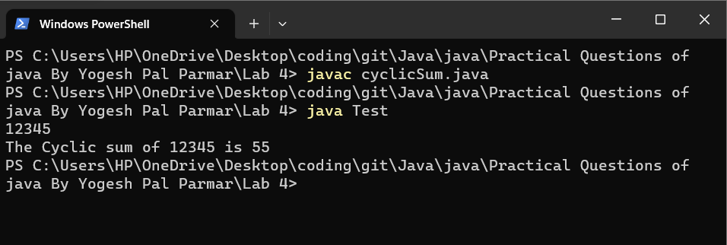

1. **Create PIN using three given input numbers "Secure Assets Private Ltd", a small company that deal with digital lockers which can be locked and unlocked using PINS (password). You have been asked to work on the module that is expected to generate PINS using three input numbers.**

**Assumption:**

**The three given input numbers will always consist of three digit i.e. each of them will be in the**

**range >=100 and <=999**

**100<=input1<=999**

**100<=input2<=999**

**100<=input3<=999**

**Below are the rules for generating the PIN**

**-The PIN should be made up of 4 digits.**

**-The unit (ones) position of the PIN should be the least of the once position of**

**the three input numbers.**

**-The hundreds position of the PIN should be the least of the hundred position of the three input numbers.**

**the three input numbers.**

**-The tens position of the PIN should be the least of the tens position of the three**

**Input numbers.**

**-The hundred position of the PIN should be the least of the hundreds position of the three input numbers.**

**Example 1-**

**input1=123**

**input2=582**

**input3=175**

**then PIN 8122**

**Example 2-**

**input1=190**

**input2=267**

**input3=853**

**then PIN 9150**

**Source code:**

**import java.util.Scanner;**

**class PinGenerate**

**{**

**int[] yourPin(int i1[], int i2[], int i3[])**

**{**

**int pin[];**

**pin = new int[4];**

**int i;**

**int max = -1000;**

**for(i=0; i<3; i++)**

**{**

**if(i1[i]> i2[i] && i1[i] > i3[i])**

**{**

**if(i1[i]>max)**

**{**

**max =i1[i];**

**}**

**}**

**if(i2[i]> i1[i] && i2[i] > i3[i])**

**{**

**if(i2[i]>max)**

**{**

**max =i2[i];**

**}**

**}**

**else**

**{**

**if(i3[i]>max)**

**{**

**max =i3[i];**

**}**

**}**

**}**

**pin[0] = max;**

**for(i=0; i<3; i++)**

**{**

**if(i1[i]< i2[i] && i1[i]< i3[i])**

**{**

**pin[i+1] = i1[i];**

**}**

**else if(i2[i]< i1[i] && i2[i]< i3[i])**

**{**

**pin[i+1] = i2[i];**

**}**

**else**

**{**

**pin[i+1] = i3[i];**

**}**

**}**

**return pin;**

**}**

**}**

**class Test**

**{**

**public static void main(String[] args)**

**{**

**int i1[];**

**i1 = new int[3];**

**int i2[];**

**i2 = new int[3];**

**int i3[];**

**i3 = new int[3];**

**int pin[];**

**pin = new int[4];**

**Scanner sc = new Scanner(System.in);**

**int i;**

**for(i=0; i<3; i++)**

**{**

**i1[i] = sc.nextInt();**

**}**

**for(i=0; i<3; i++)**

**{**

**i2[i] = sc.nextInt();**

**}**

**for(i=0; i<3; i++)**

**{**

**i3[i] = sc.nextInt();**

**}**

**PinGenerate ob = new PinGenerate();**

**pin = ob.yourPin(i1, i2, i3);**

**System.out.print("Your Unique PIN is " );**

**for(i=0; i<4; i++)**

**{**

**System.out.print(pin[i]);**

**}**

**}**

**}**

**Output:**

